

**Assignment Cover Sheet**

To be completed **electronically** by the student and submitted with each piece of work. Please upload this completed cover sheet via Turnitin

**Assignment Title:** Web Dev II - Clone Tasks

**Tutor:** Usman Ahmad

**Student Name:** Jose Enricky V. Belmin

**Student Number:** 521487

**Date of Submission:** November 4, 2023

**Details of your submission**

| ***GitHub Link*** | [BSU-Creative-Computing/assignment-1-clone-tasks-JoseBelmin: assignment-1-clone-tasks-JoseBelmin created by GitHub Classroom](https://github.com/BSU-Creative-Computing/assignment-1-clone-tasks-JoseBelmin) |
| --- | --- |
| ***Class Activities Link*** | [Web-Dev-II/Class Activities/SCSS at main · JoseBelmin/Web-Dev-II (github.com)](https://github.com/JoseBelmin/Web-Dev-II/tree/main/Class%20Activities/SCSS) |

In submitting this assignment, I am confirming that I have read and understood the regulations for assessment, and I am aware of the seriousness with which the University regards unfair practice. Please see the university's [Unfair Practice Policy](https://thehub.bathspa.ac.uk/reference/student-policies/unfair-practice-policy) for details.

Signed: Date: November 4, 2023

**Clone Task 1:**

*//Paste Screenshots of the web page on different resolutions*

| Clone Task 1 Folder: | [assignment-1-clone-tasks-JoseBelmin/Assessment 1/Task 1 at main · BSU-Creative-Computing/assignment-1-clone-tasks-JoseBelmin (github.com)](https://github.com/BSU-Creative-Computing/assignment-1-clone-tasks-JoseBelmin/tree/main/Assessment%201/Task%201) |
| --- | --- |
| YouTube Link: | <https://youtu.be/I11_g1skStE> |

Task 1-1 (Above 1024px)

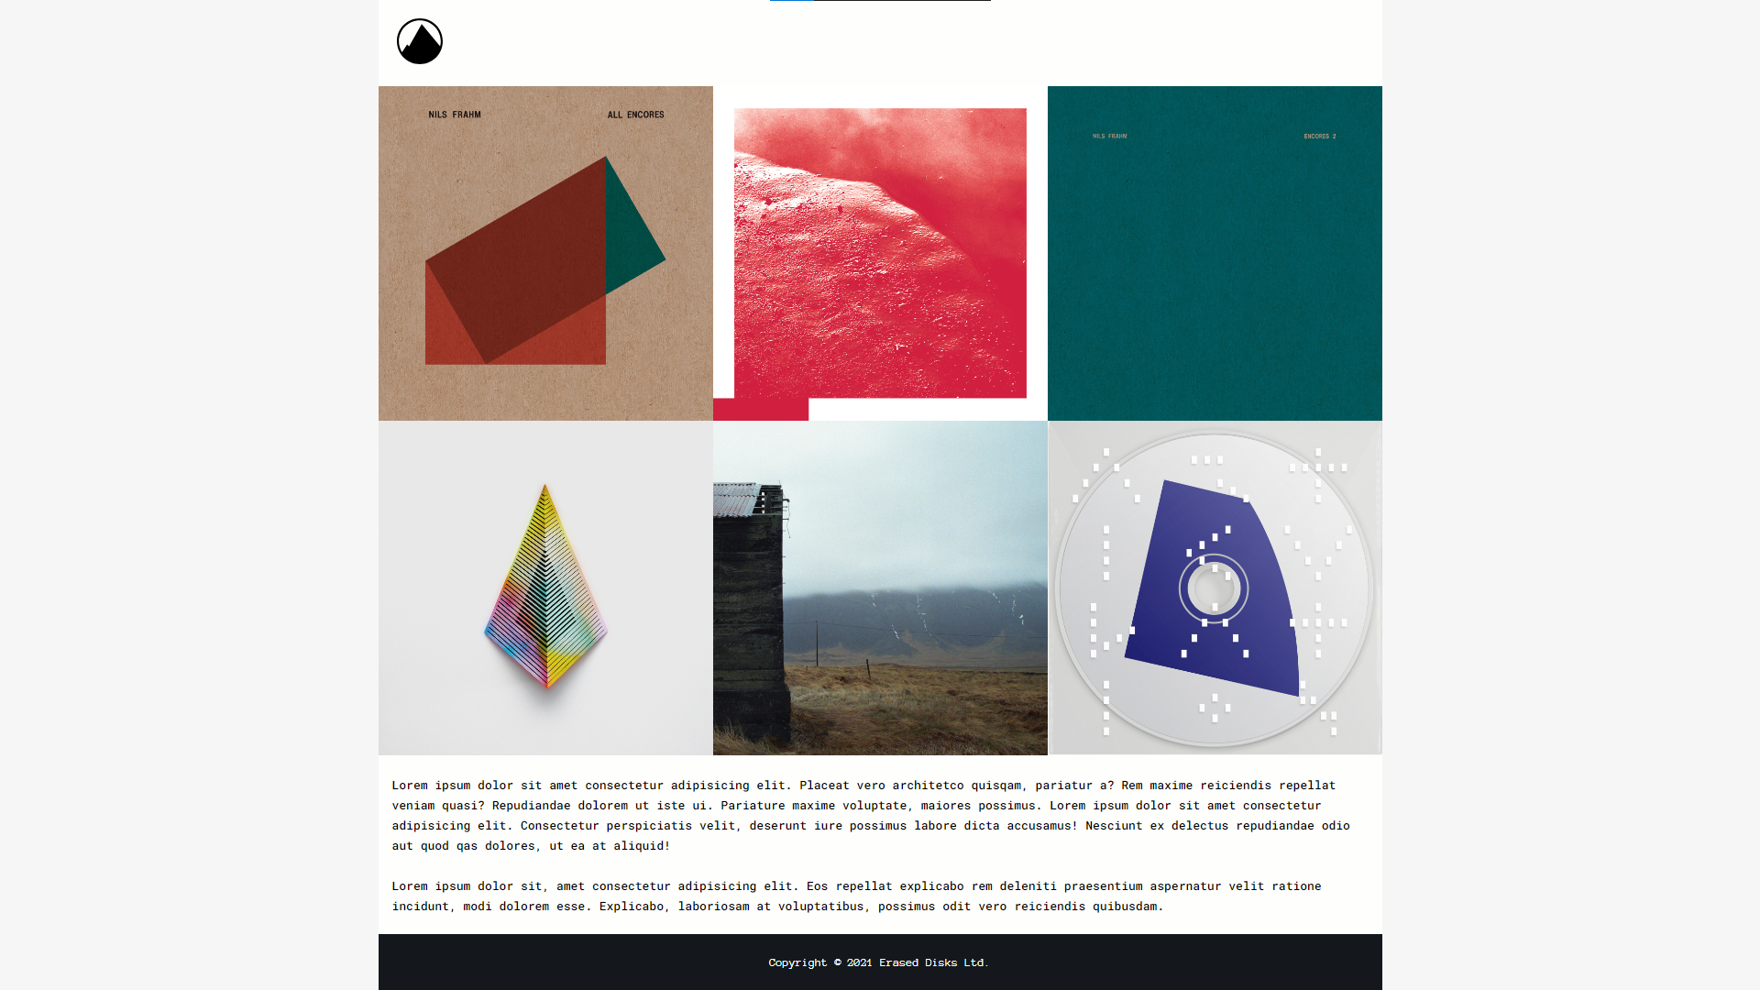

Task 1-2 (1024px)

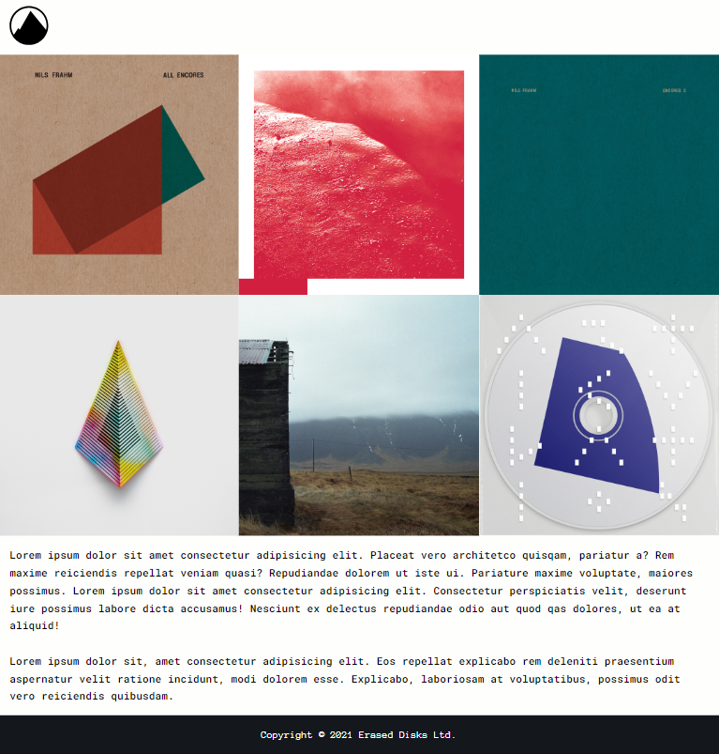

Task 1-3 (800px)

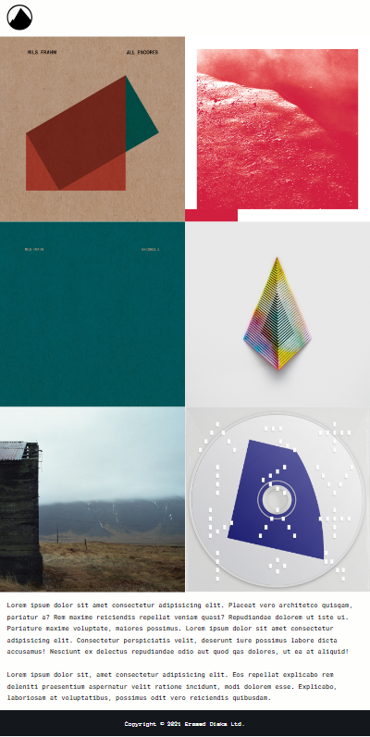

Task 1-4 (480px)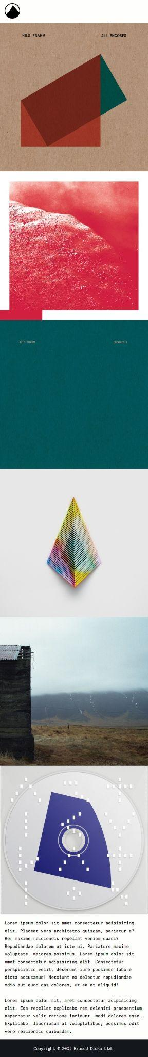

**Clone Task 2:**

*//Paste Screenshots of the web page on different resolutions*

| Clone Task 2 Folder: | [assignment-1-clone-tasks-JoseBelmin/Assessment 1/Task 2 at main · BSU-Creative-Computing/assignment-1-clone-tasks-JoseBelmin (github.com)](https://github.com/BSU-Creative-Computing/assignment-1-clone-tasks-JoseBelmin/tree/main/Assessment%201/Task%202) |
| --- | --- |
| YouTube Link: | <https://youtu.be/rT9n4hzkhgw> |

Task 2-1 (Above 1280px/1477px)

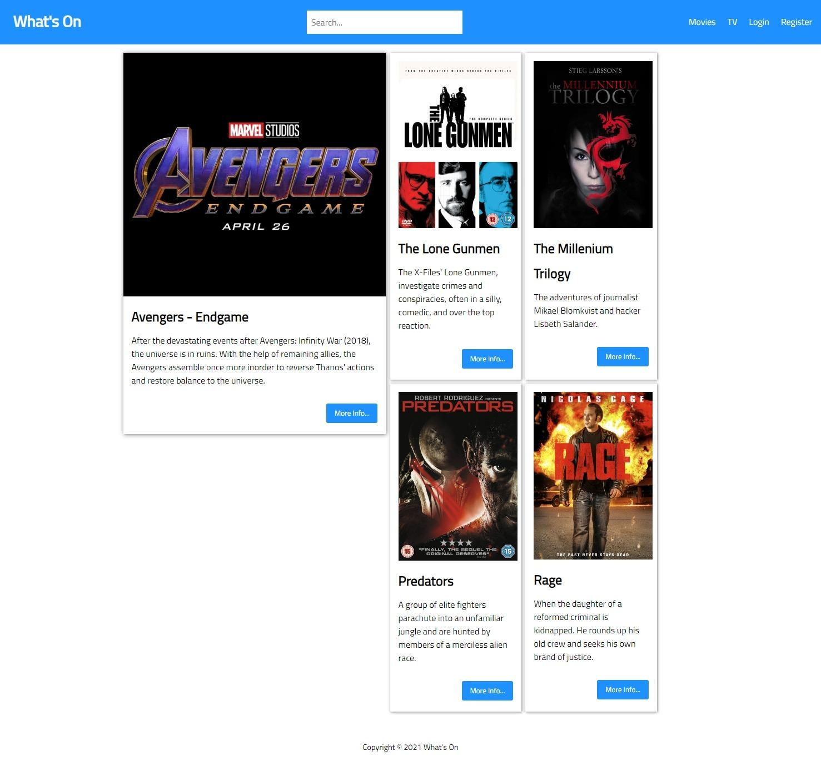

Task 2-2 (1280px)

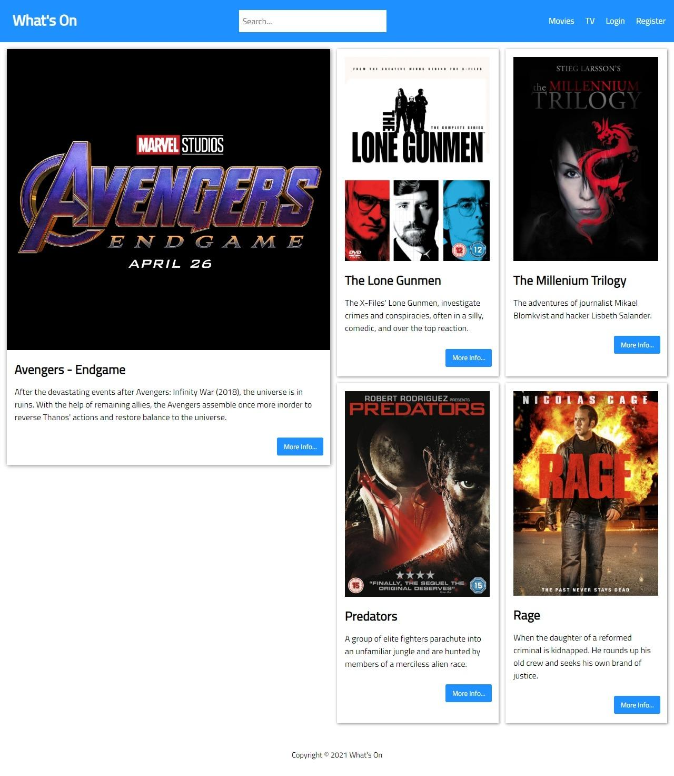

Task 2-3 (1024px)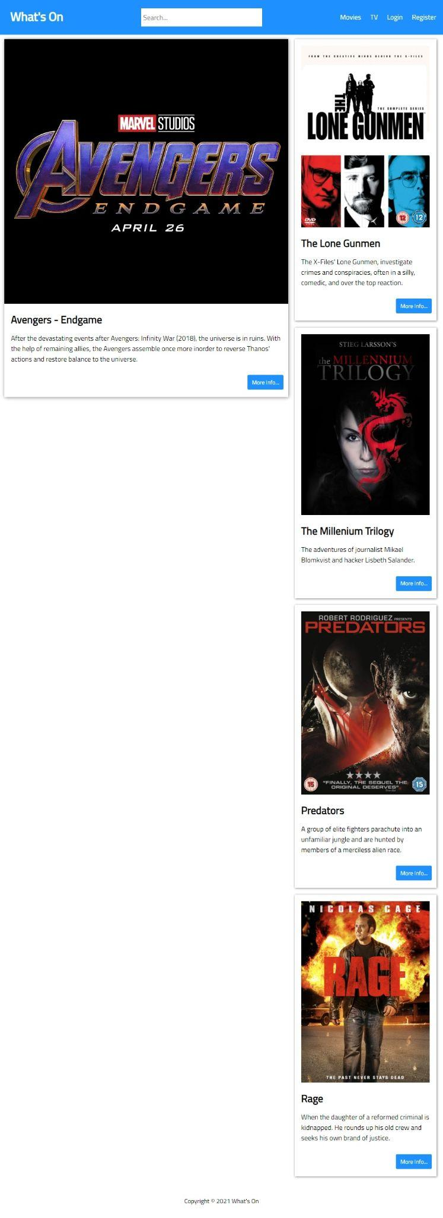

Task 2-4 (800px)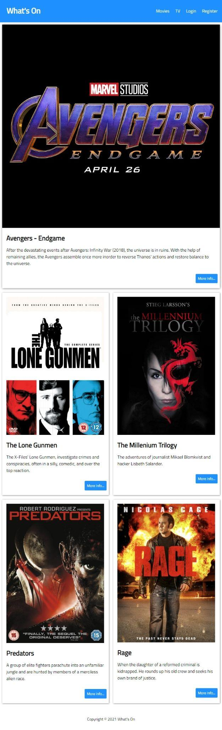

Task 2-5 (400px)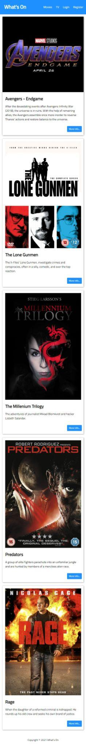

**Clone Task 3:**

*//Paste Screenshots of the web page on different resolutions*

Task 3-1 (1280px)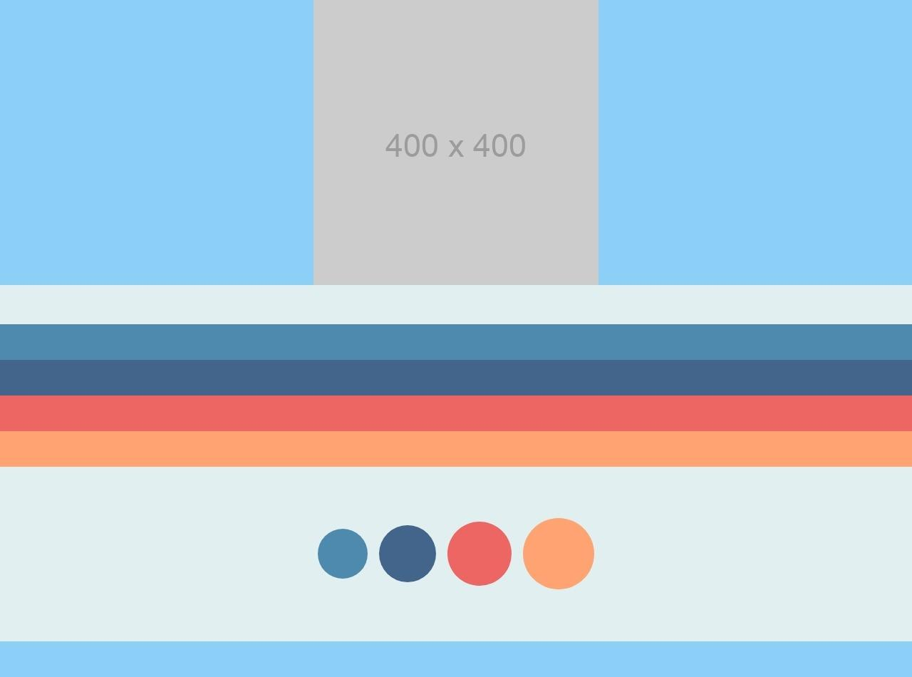

Task 3-2 (1024px)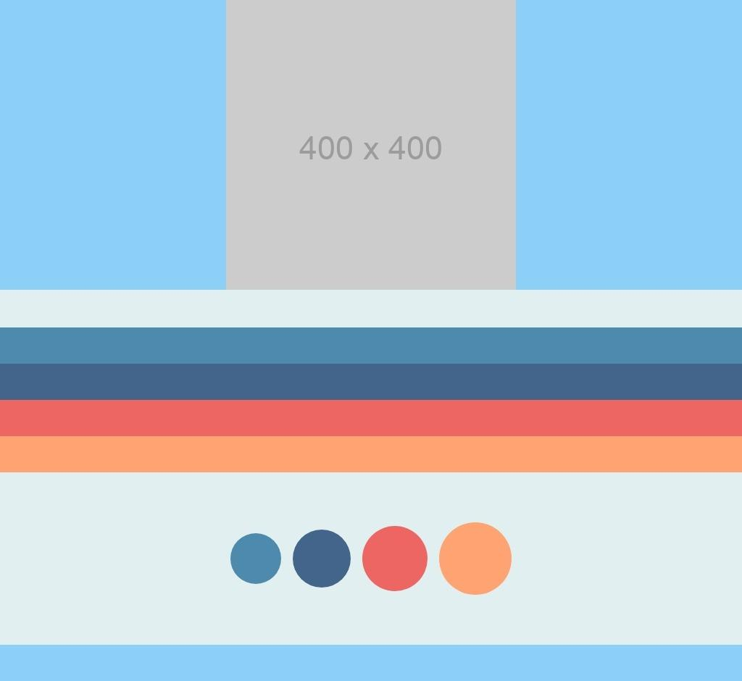

Task 3-3 (620px)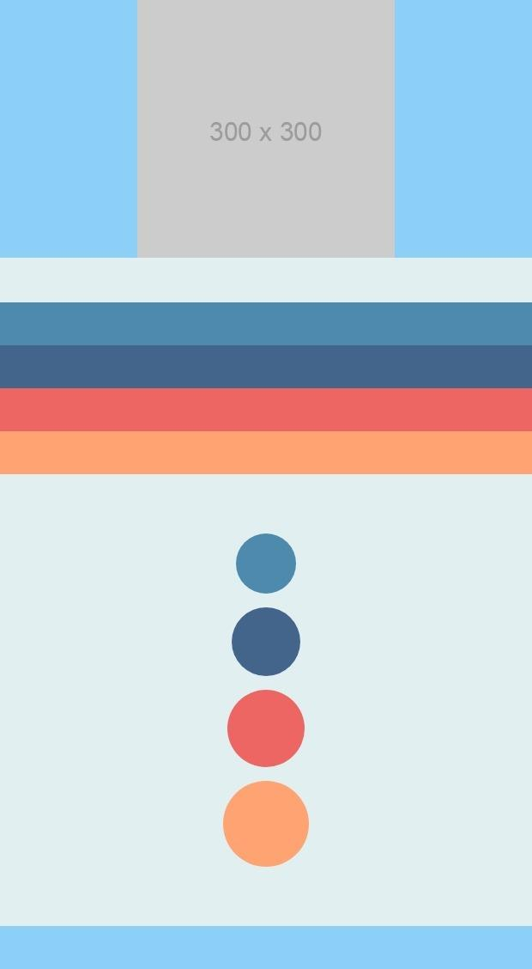

Task 3-4 (480px)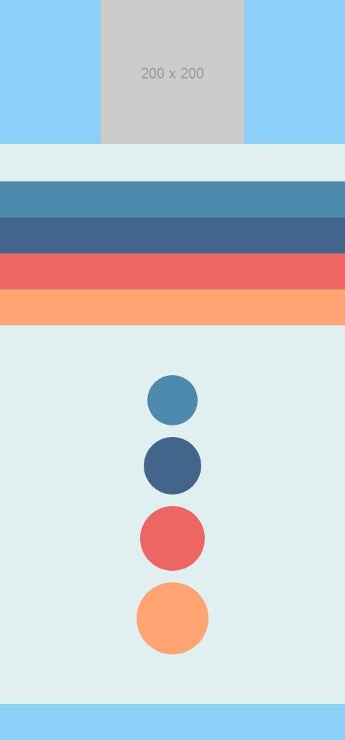

| Clone Task 3 Folder: | [assignment-1-clone-tasks-JoseBelmin/Assessment 1/Task 3 at main · BSU-Creative-Computing/assignment-1-clone-tasks-JoseBelmin (github.com)](https://github.com/BSU-Creative-Computing/assignment-1-clone-tasks-JoseBelmin/tree/main/Assessment%201/Task%203) |
| --- | --- |
| YouTube Link: | <https://youtu.be/Bam-czbboDU> |

**LinkedIn Course Completion Certificate (Optional)***